Project - Final

**Introduction and Project Scope........................................................ 1**

**Requirement Elicitation..................................................................... 3**

Survey............................................................................................. 3

**Research Summary............................................................................ 9**

**Market Analysis................................................................................ 11**

**Method of working............................................................................ 12**

**Assumption testing and validation................................................ 13**

**Prototyping........................................................................................ 16**

**Ethical Audit...................................................................................... 18**

**Evaluation of project........................................................................ 18**

**Conclusion........................................................................................ 19**

# **Introduction and Project Scope**

Our main objective is to create a comprehensive web application with the purpose of motivating South Asians to lead a healthy lifestyle in an effort to combat diseases that are commonly found within this ethnic group. South Asian countries are now technologically advancing with more of the community having access to the internet and mobile phones. This proposal dictates the design choices as well as new developments that the project has taken and discusses reasons behind the choices we have made.

The criteria of the project is to be deemed successful once all of our desired features are implemented fully into our project. For example, the criteria of our project is to design an web app that promotes the unique needs that are catered specifically towards the South Asian community regarding health and fitness. Another criteria is the increased number of South Asian groups engaging in a more healthy and physical lifestyle. It is vital to set out goals and objectives that will help us meet our criteria in order for our project to be successful.

We can ensure that we meet the goals and objectives by defining the scope of our project. The scope of our project would be the completion of our web application with all its features and functions operating successfully. There are many features that have to be created in order for our project to be successful. One design requirement of our web application is to create an intuitive user interface that is relatively simple to use and is accessible for users of all ages. We plan for our web application to be accessible on both desktop and mobile platforms to extend its exposure to every possible user whilst still maintaining an easy and user friendly experience for both platforms. Features that we will be present in our project is a good documentation of health risks imposed on South Asians. It is important that these health tips and statistics are cited and taken from a reliable source. To meet the criteria of our project, the tools we will implement should encourage users to embody a healthier lifestyle and simplify the effort a person needs to adopt such habits. We intend to implement interactive features of the web application such as providing workout and dietary plans, a fitness journal and BMI calculator as these fit within our final objectives when we provide our project deliverables. Dietary plans can align with existing recipes that are common in the South Asian community, this makes it easier for people to transition to their new dietary plans and these features will grant the user a friendlier experience.

Furthermore, features such as a log in/sign up database, achievement tracker and calorie calculator will be added to our web application. To successfully achieve these features, it is crucial we understand how to develop and integrate such features. It requires knowledge of multiple languages e.g. HTML, CSS, JavaScript andSQLite. This is due to the fact our web application will have both front end development and back end development, SQLite will be used to store user information, ensuring users are met with an exclusive visit to the web application. Including features using a SQLite database requires our group to be able to code in this language and maintain the database efficiently so user information is secured. All group members are familiar with HTML, CSS and JavaScript languages, although only some of the group members can use SQLite. Users will be able to log in and sign in to their accounts, they are also able to access and manage their profile, with access to documentation about raising awareness about health risks that are dominant in the ethnic group. It will be difficult to implement an algorithm that examines the correct amount of calories that a person should take, this is due to the fact we do not have medical experience so a user should refer to an actual medical advisor.

There are some limitations to the project as a whole such as time constraints, technological and resource limitations. To combat such issues, we must set out milestones that plan the development of our project step by step. This allows for a smoother development process as well as planning the allocation of resources/time effectively. The creation of this report is only constrained to 6 weeks.

Also, we must take into consideration the stakeholders needs in our project, this makes sure we do not stray away from the initial problem that has been stated. The stakeholders requirements align with the goals and objectives of our project so it is vital that they are met. Users expect a comprehensive web application that provides the features to solve the problem that is prevalent in the South Asian community. Stakeholders such as personal trainers and paediatricians should be compelled to refer to our web app as they expect it to have accurate health information that will be useful for patients, this will act as an alternative for patients to consult.

**Background**

A fitness online app designed with South Asians in mind can address a number of crucial issues and offer a more individualised and culturally relevant experience. The following are some possible motivations to creating such an app:

Taking care of health issues that are common in South Asian communities: Due to genetic predispositions and lifestyle factors, South Asians are more likely to develop certain health disorders, such as obesity, cardiovascular illnesses, and type 2 diabetes. To encourage preventive care and healthy living, a fitness app created especially for this group can assist spread awareness and offer resources that are precisely tailored to their needs.

Taking into account nutritional and cultural preferences: South Asian diets and cuisines are distinctive and have strong cultural roots. An app that takes these preferences into consideration when recommending meals and exercise regimens can boost user engagement and make it simpler for people to acquire and stick to healthy habits without sacrificing their cultural identity.

Providing education and encouragement that is culturally appropriate: Encouraging people to take up healthier lifestyles can be difficult, particularly when cultural hurdles or misunderstandings are present. A fitness app with a South Asian target audience can provide success stories, educational materials, and community support that speak to the target demographic and increase the chance of long-term involvement.

Promoting body positivity and addressing body image problems: challenging beauty standards and problems with body image can be detrimental to one's mental and physical well-being. An app for fitness targeted to South Asians should emphasise holistic health, celebrate diversity, and encourage body positivity instead of following potentially dangerous social expectations.

# **Requirement Elicitation**

The methods that we have chosen for gathering requirements are interviews, ethnography and focus groups. This is to emulate a funnel-based approach, starting with surveys as broader research and then gradually narrowing down to more specific requirements with ethnography and finally to validate our findings and carry out a focus group. However, due to time constraints we were not able to organise a focus group.

## **Survey**

The initial method we have deployed is a concise quantitative survey comprising 10 closed-ended questions. Although the survey may not delve into intricate details, its user-friendly design and non-thought-provoking nature has proven to result in a higher response rate. Within 3 minutes, we had 3 surveys already filled out. This is also credited to the flexibility in its distributive nature, which enabled us to share it through emails, forums, and social media.

**Survey questions and analysis:**

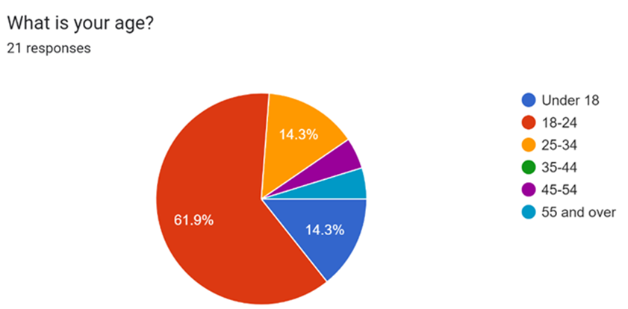

The survey distribution was straightforward, successfully reaching our target participation goal of 20-25 respondents. However, the participants exhibited limited diversity in both age groups and cultural backgrounds.

The lack of monitoring was an issue, but it was deemed necessary to compromise to obtain an overview of the South Asian community. While the focus was on ensuring that only the intended demographic participates in the survey, this compromise introduced concerns about the overall integrity of the gathered data as some who are not part of the South Asians communities have evidently participated in the survey, as “or other”.

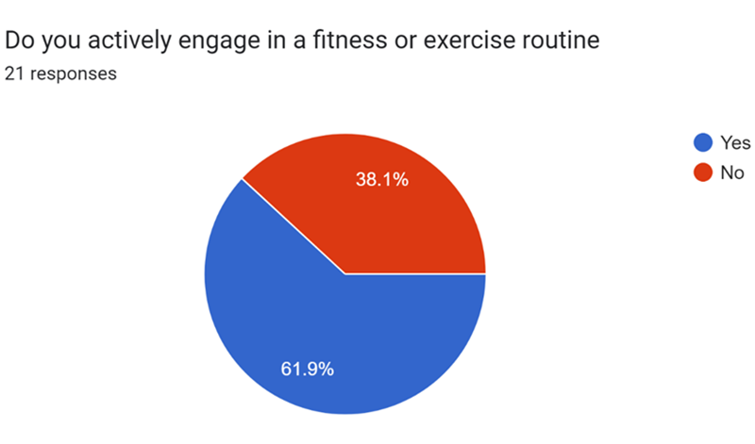

More than half the participants are actively engaged in fitness, indicating a significant interest in the domain of our project. However, the presence of inactive participants is unsurprising as there may be different factors that stop people from being active which needs to be explored further.

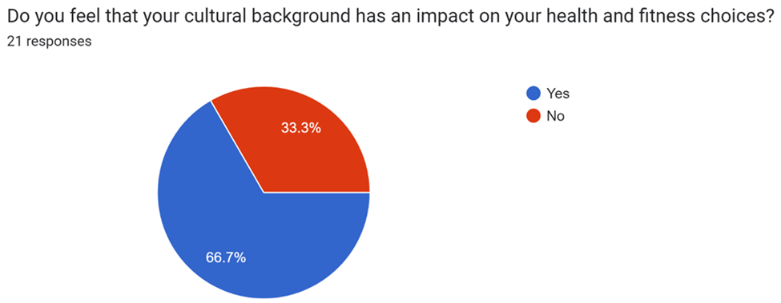

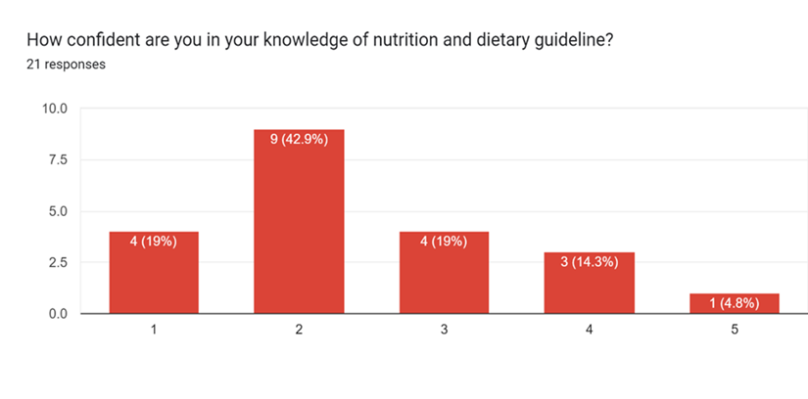

|  |  |
| --- | --- |
|  |  |

The impact of cultural background on health and fitness choices in South Asian communities remains ambiguous. as the question lacks clarification on whether the influence is positive or negative. We don’t know whether it had a good or bad impact. While the connotation of "impact" often implies a negative association, leading to assumptions about the participant's understanding of the question, clarification would have been beneficial as it would have provided more credibility to the data set.

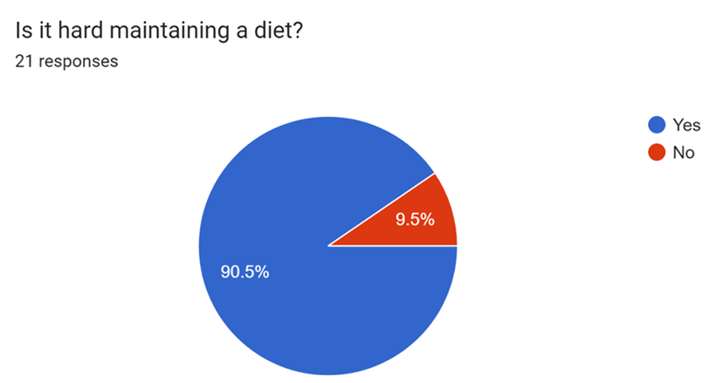

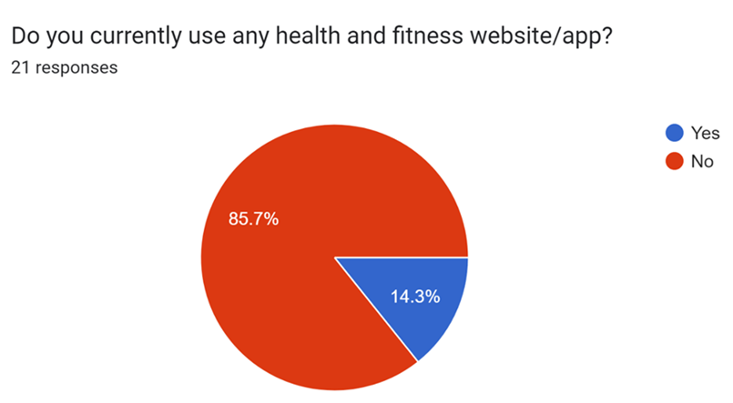

A significant number of people don't actively use health and fitness websites or apps. Possible reasons, like lack of awareness, a preference for in-person support, or dissatisfaction with available apps, remain speculative.

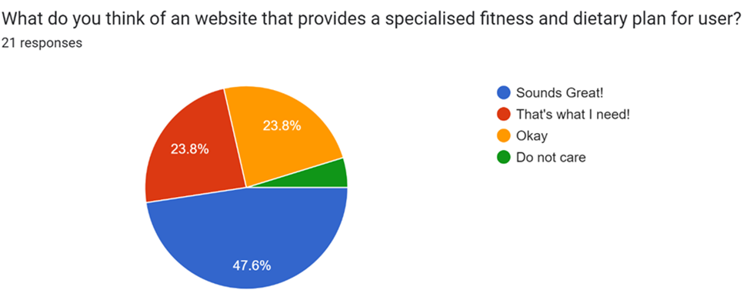

# 

This gives us encouragement to make sure this feature is implemented as the response has been overly supportive.

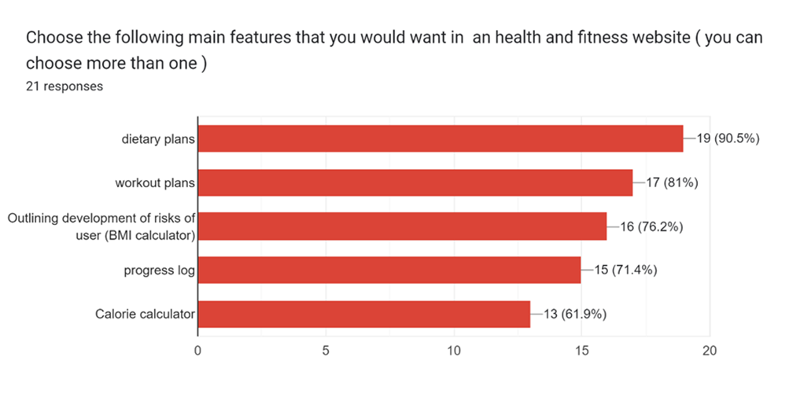

# 

# 

# 

Finally, we inquired participants to choose main features proposed for implementation in our web application. The results highlight key insights: although all features received votes exceeding 70%, dietary plans emerged as the favourite, signalling its importance as a crucial and sought-after feature for our application.

**Ethnography:**

The second method we carried out was ethnography, a qualitative research approach that involved immersing ourselves in the daily lives of individuals from the South Asian community. The participant for this research is named Bilal Ahmed, and we agreed to conduct the research for one week.

**Background:**

Bilal, a 22-year-old man of Indian descent, resides in Ilford, a multicultural neighbourhood. He is a full-time university student and works part-time as a retail supervisor at Primark. He lives with his parents and his two younger sisters. This study focuses on his diet, exploring the kinds of food consumed throughout the day, his physical activities, and cultural engagement, all of which impact his health and fitness.

**Dietary Habits:**

On an average day, his morning breakfast consists of traditional Indian cuisine, such as three parathas (Indian flatbread) accompanied by two egg omelettes. However, due to time constraints on workdays (weekdays), he occasionally opts for quicker options like a bowl of cereal or toast with peanut butter and jam.

For lunch, Bilal often carries homemade Indian meals to university or work. These meals typically include white rice, dal (lentil dish), a small portion of vegetable dish, and a protein source such as chicken or meat curry. Occasionally, he resorts to meal deals from Tesco or the university campus cafeteria.

Dinner is consumed as a family, where traditional Indian dishes take centre stage. Bilal's mother prepares a variety of curries, dals (lentil dishes), and rotis (Indian bread), ensuring a balanced and culturally rich dinner experience. This occurs about four times a week, meaning the rest of the week is eaten out. Right after university or work, he eats out with his friends at various restaurants, mostly consuming fast food such as burgers, fries, and wings.

**Physical Activities:**

Bilal's physical activities vary based on his schedule. On university days, his commute involves walking and cycling, contributing to his daily physical exercise. Additionally, he engages in weekly football matches with friends, providing both a social and physical outlet. During busier weeks, Bilal doesn't indulge in any activities at all, and during free time, he seemed unbothered to incorporate any physical workouts. He lacks motivation and requires something to initiate him.

Cultural Engagement:

Bilal actively engages in cultural events organised by the local South Asian community, making a point to attend festivals, religious ceremonies, and community gatherings. These occasions often feature a rich array of traditional foods, providing a sensory experience that connects him to his cultural roots.

Additionally, Bilal participates in "dawats" (invitations) occasionally. These gatherings, hosted by relatives or family friends, are centred around the shared purpose of dining together. During these events, Bilal experiences a diverse range of Indian traditional cuisines, showcasing the culinary richness of his heritage.

# 

# **Research Summary**

Some challenges that we will face when building this web application is that the south Asian community is a diverse community with multiple different languages and traditions that impact their health perspectives and due to a large population of this community being spread throughout the world, many south Asians have inherited cultures from other parts of the world making our tasks of tailoring it for the community as a whole more challenging. As a result of this a lot of research will be needed to take place as the fitness web app will need to be accommodating to a lot of different cultures. In addition to this, south Asians are more likely to be faced with certain diseases such as heart disease and diabetes, this has led to our web app needing to be better tailored to individuals in order to tackle these issues as we will need to consider the accessibility individuals have to food, gyms and professional services due to the Asian community varying on income and quality of life. To solve this, we have made a price plan so that people can choose based on their budget. We have also made different levels so that people know what stage they are on.

Foremost challenges that we will face is dealing with major competitors who have already built a large name for themselves. As for our web app it will be difficult to target our community as a whole due to the varying levels of technological access and in addition to this popular fitness apps such as peloton and MyFitnessPal have no limitation to who they are looking to target and are already very popular with having high ratings and good reviews on both App stores and online, it has already given these companies a large advantage above other competitors, however our web app is focused on being more tailored to individuals and aims to provide a greater ease of use to south Asian community it could allow us to attract a large community as major competitors right now are not focused on specific communities.

Further obstacles that will be faced include dealing with cultural norms within the south Asian community, as men and women are expected to live very different lifestyles. As stated in an article written by Zulkarnain Jaafar called “Understanding factors behind low levels of physical activity in south Asian immigrants”, south Asian culture makes it difficult to adopt an exercise regimen as women are expected to bear a greater responsibility to tending to children and maintaining their household duties leaving little time to tend to their fitness and exercise time.

Challenges that we face as for developing the web app itself, is that we will need to manage sensitive data and will be required to follow data regulations set by governments in order to protect user privacy, to tackle this we will need to implement heightened security measures, encryption protocols as well as two factor authentication.

As well as this, South Asian dishes share common ingredients which contain lots of fats and carbohydrates which a lot of their dishes are based around and finding suitable alternatives to this is not easy due to it being easily accessible by people of both low and high income, for example rice is an ingredient which cannot be easily provided an alternative for and can be accessed by both poor and wealthy families.

Finally, a lot of the south Asian community’s struggle with slow internet connections and use of older devices makes it difficult to handle up to date apps and features, as a result of this our web app will need to consider the various range of devices and be responsive and function well. As well as this it should provide a user-friendly interface as users may be from different backgrounds and upbringing, we will need to adapt our web app to allow ease of use by being mindful of the user's technological literacy which could be done by providing tutorials and instructions. By addressing these challenges alongside constant testing and user feedback throughout the development process, our aim to overcome these obstacles can be tackled in the upcoming weeks and result in a successful web application.

# **Market Analysis**

There are many existing and well established fitness applications although they do not specifically cater to our stakeholders needs, some features that are present in these applications will be beneficial to add to our web application. MyFitnessPal for example is an application based on phones that helps users track and log calories. This will be useful on our web application in the development of our calorie calculator.

The top 5 websites that appear when searching for health and fitness. Users are recommended for applications such as Centr, Jefit, Nike Training Club, and MyFitnessPal. MyFitnessPal is one of the most used among users with its success due to how easily accessible it is. Many factors play into why it is very successful, one reason could be that it is available on mobile phone platforms and is a free application with some paid features. When using the application, the design of the user interface is intuitive and relatively easy to interact with as a new user. The process of creating an account in MyFitnessPal ensures that the user is receiving a personalised user profile by asking questions such as “What is your age, gender, height and weight?”, also “What type of experience are you looking to get from this app?”. The app can then use the answers to create a personalised experience for the user.

It is important to note down the critiques of these apps and any possible flaws that we can resolve in the development of our web application. Criticism from the app's users will aid us in finding improvements to the existing system as improvements for the app are already listed by them. One flaw of the application is the fact that there are features exclusive to only paid users. This means not all features are accessible for users who cannot afford paying a monthly subscription. Another flaw that users mention is the lack of correct information about food in the database, so this will affect a user’s diet. One improvement would be offering correct nutritional information that has been reliably sourced by medical professionals and cultural consultants. This would be a good time to enter into the fitness industry as there seems to be a lot of opportunities due to the demand. For example, many people would prefer an in person trainer than an app. This would give opportunities for companies to make a website for gym trainers to show their portfolio. The market size of the fitness industry seems to be growing year on year with it being at 1.8 billion in 2022. More people seem to need these apps as according to the national library of medicine, more than 60 % of people who have diabetes live in asia. It is estimated that by 2045, India will have 124.9 million people diagnosed with diabetes.

This can cause major problems as many of them will be able to get these apps as it can be unaffordable for many people in these countries. To solve this, we must make sure that we make our pricing affordable so that we can get many people to choose our app since we will be targeting their community.

# **Method of working**

Using the iterative design process, User-centred design is vital for creating our web app, this is because it focuses on our users needs and expectations. Having our users involved throughout the process will help us successfully create a highly usable , accessible and useful web app for them for them, so for example our web app is targeted towards the south asian community, thus throughout the process our users, the south asian community will be involved throughout every stage of the process of creating this web app. Our motivation from us doing this is that many people in the south asian community do not look after their health and fitness meaning that many may suffer consequences in the future due to this meaning that many people will need services that will help them not suffer these consequences as it will badly affect their health. The south asian community seems to have one of the most diabetic populations amongst the world meaning that we should target them in order to get statistical change in the future so that the population can live healthier and longer lives.

To successfully achieve this we will be working in multiple phases, first is the research phase, in this phase our goal is to understand the users, their needs, and expectations. Currently we are conducting multiple research methods such as surveys, Ethnography and focus groups. By using ethnography we can engage with the community over an extended period allowing us to build trust and rapport, making it more likely for participants to share honest feedback about their health and fitness needs as a result gain a holistic understanding of a group's way of life, beliefs, practices, and interactions. If done correctly we will be able to gain rich and contextually relevant data which will benefit us in creating a fitness and diet app that resonates with and effectively serves the South Asian community. Furthermore, using surveys enables us to reach a broad South Asian community through various channels, including online platforms, email, or paper-based forms. Focus groups will most likely be our most important method of research as South Asian communities have unique dietary preferences, cultural practices, and genetic predispositions that can affect their health and fitness goals. A focus group can help us gain cultural insights and ensure our application resonates with these specific factors. Thus we can gain a deeper understanding of what South Asian users are looking for in a fitness and diet app.

After the design phase we will move into the design phase where our goal is to generate ideas and solutions based on the insights we will gather during the research phase. So during this phase we will create low and high fidelity prototypes to visualise the structure and layout of the web app, we incorporated feedback from the research phase to create a design that is not only functional but also culturally sensitive and appealing. Next we will conduct usability testing on prototypes to gather early feedback from users. Here will pay attention to how well users from diverse backgrounds navigate the app, understand the content, and engage with the features.

Finally, after testing the prototype and obtaining user input, our objective for the evaluation phase is to assess the outcomes and pinpoint areas that want improvement. We'll examine user input to find recurring trends, issues, and commendable points raised. Therefore, we will make the necessary changes to improve accessibility and ensure a positive experience for all users. Some of these changes include the design elements, colour schemes, imagery, and language used. Additionally, we may add specific exercises and meals to avoid diseases like stomach cancer and type 2 diabetes, which are common in the South Asian community, for one of our users who speaks a language that we did not include. We will therefore iterate over the design and make adjustments in light of the evaluation's results.

# **Assumption testing and validation**

The ShapeShift development methodology relies heavily on assumption testing and validation. Understanding the South Asian community's various levels of knowledge with fitness ideas is critical. Surveys, interviews, and pre-tests should be used to measure users' baseline knowledge, in keeping with the objective of catering to a varied audience. The design for formative testing should contain metrics for measuring users' baseline knowledge as well as user input and objective measurements of knowledge development. The design decision presupposes an iterative process for refining fitness idea knowledge, necessitating phases for testing instructional components and capturing user comprehension in the prototype. A critical examination should address difficulties in developing instructional material, techniques for retaining interest, and assessing knowledge retention.

Assuming varied levels of technology expertise, ***User-centric design*** necessitates a methodical approach to requirements collecting. User interviews and surveys should provide a thorough understanding of users' technology backgrounds. The choice to create an intuitive interface coincides with the ideals of inclusion, and the strategy for early prototypes and usability testing is noteworthy. Beyond basic usability measures, the assessment should involve a varied collection of users from the target population, taking cultural relevance and emotional engagement into account. Recognizing possible biases in user selection is critical before offering mitigating solutions. The choice to create prototypes is consistent with best practices, and the strategy should include the transition from low-fidelity to high-fidelity prototypes. A critical analysis should address issues in the prototype process, such as possible biases and cultural relevance in evaluation, and should recommend solutionsfor unbiased assessments.

***Cultural sensitivity*** necessitates a sophisticated approach, considering multiple cultures within the South Asian population. Ethnographic research, focus groups, and contact with culture specialists should all be included in the requirements gathering process. The use of cultural components in the design correlates with inclusivity, and the formative testing and evaluation strategy should describe how cultural relevance will be judged. It is important to emphasise the iterative nature of evaluating cultural aspects and the flexibility to modify based on input. A critical examination should address the issues of effectively depicting multiple cultures and provide ways for validating cultural aspects' authenticity. Beyond usability, the evaluation should include indicators of cultural authenticity, user pleasure, emotional reactions, and perceived cultural significance.

***Accessibility,*** assuming users access the web app from a variety of devices, necessitates knowledge about preferred gadgets in the South Asian population. To inform responsive design decisions, requirements should be gathered through device preference surveys or interviews. The decision to employ responsive design corresponds with the goal of offering a consistent user experience. The formative testing strategy should specify how the responsiveness of the web app will be evaluated on various platforms, recognizing potential difficulties and offering techniques for representativity. The prototype should demonstrate how responsiveness is maintained across several devices. A critical examination should address the difficulties in maintaining a uniform user experience, as well as ways for dealing with device-specific concerns. The review should contain metrics pertaining to the web app's performance on various devices, with an emphasis on visual uniformity.

Users must engage fluidly with features during ***Prototype testing*** in order to discover user expectations and pain areas. To capture user expectations, requirements should be gathered through interviews or surveys. The choice to create prototypes is aligned with creating a user-friendly experience, and the formative testing strategy should define metrics used to evaluate smooth interactions. The assessment should include a varied range of users, taking into account potential difficulties in feature comprehension. It is critical to recognize potential biases in user self-reporting and to provide solutions for triangulating data. The construction of the prototype should demonstrate how features are evaluated iteratively, addressing issues in prototyping complex features and offering ways for capturing varied user interactions. The assessment should contain measurements for feature usability, efficiency, and user happiness, as well as user input at various stages of prototype.

***Security measures***, assuming the need to secure user data, security methods necessitate a thorough grasp of user privacy concerns. Surveys or interviews should be used to gather requirements in order to capture user expectations about data security. The design decision to enable secure authentication and data encryption coincides with the priority of protecting user data. The formative testing strategy should specify how security measures will be assessed, recognizing possible difficulties in reproducing real-world security risks and offering techniques for thorough testing. The prototype development should demonstrate how security elements are integrated into the system design, addressing implementation issues and providing ways for balancing security and user ease. The review should contain metrics relating to the strength of security measures, and security specialists should be included for a full assessment.

***Iterative design*** necessitates a methodical awareness of evolving customer requirements. Continuous surveys and feedback loops are required for requirements collecting in order to capture changing user expectations. Iterative design corresponds with adjusting to changing user demands, and the formative testing strategy should define how iterative design will be tested. Continuous feedback loops and measurements on user satisfaction over time should be used in evaluation. It is critical to recognize issues in consistent user input and to propose ways for continued participation. Prototyping should show how user feedback is incorporated into iterative design cycles, as well as addressing issues in managing ongoing iterations and suggesting ways for meeting project deadlines. Metrics on the efficacy of iterative design in meeting shifting user demands, integrating inputs from users participating, should be included in the evaluation in multiple iterations.

In conclusion, assumption testing and validation remain an ongoing process in ShapeShift development. The project intends to guarantee that design decisions fit with the requirements and preferences of the South Asian population by incorporating early user feedback, conducting usability testing, and applying automated validation techniques.

# 

# **Prototyping**

As a group we have opted for a low fidelity wireframe approach to prototype any design ideas we may have. Also, this approach is beneficial to an older demographic or those who are less experienced with technology as they may not have basic knowledge when it comes to using technological applications. Below is the first low fidelity prototype. This prototype is an example of the feedback page that is to be implemented in our web application. Users will be able to give feedback and criticism to help us improve in different areas of the web app.

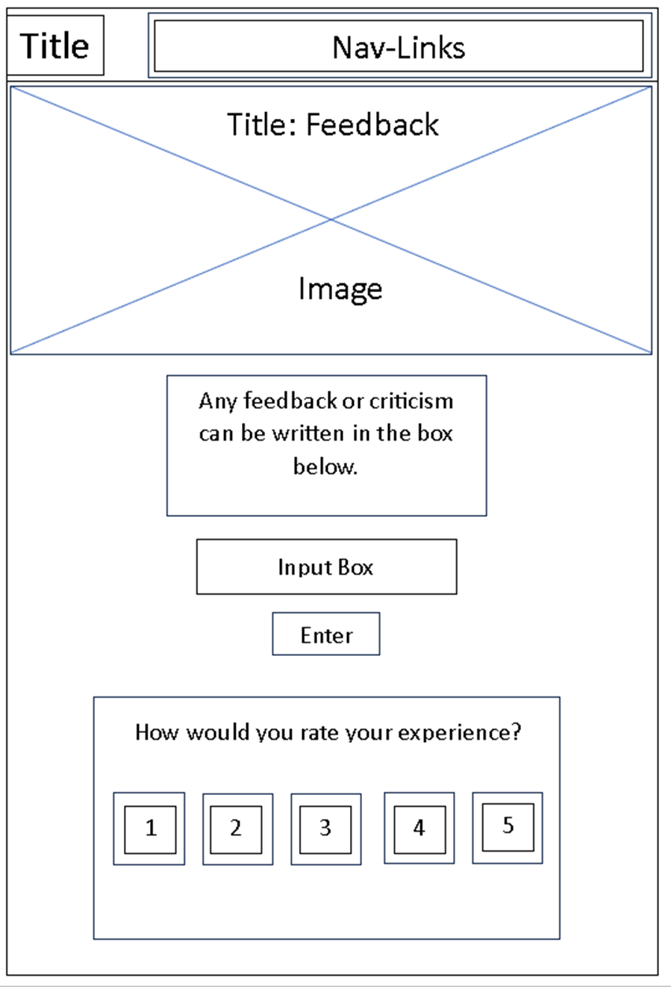

The simplified page is a form of abstraction as this will aid users to focus on the key parts of the feedback page. The design of the page is fairly simple and constructed in a way that leads the user to a feedback box. One problem from the design of the rating box (1-10) is that the scale is too small and ambiguous to give a definite answer. This must be changed so it can fit freely with the user's criticism. We also used a signup/login page so that people can save their details as well as their purchases. There would also be a price plan page where people can choose how difficult/advanced they want their fitness/dietary plan to be. The feedback would help with customer retention as people would know that they get many good reviews online by users.

**High-fidelity Wireframe**

Home Page - This will be the main page which will show all our links as well as all our services which will be presented here.

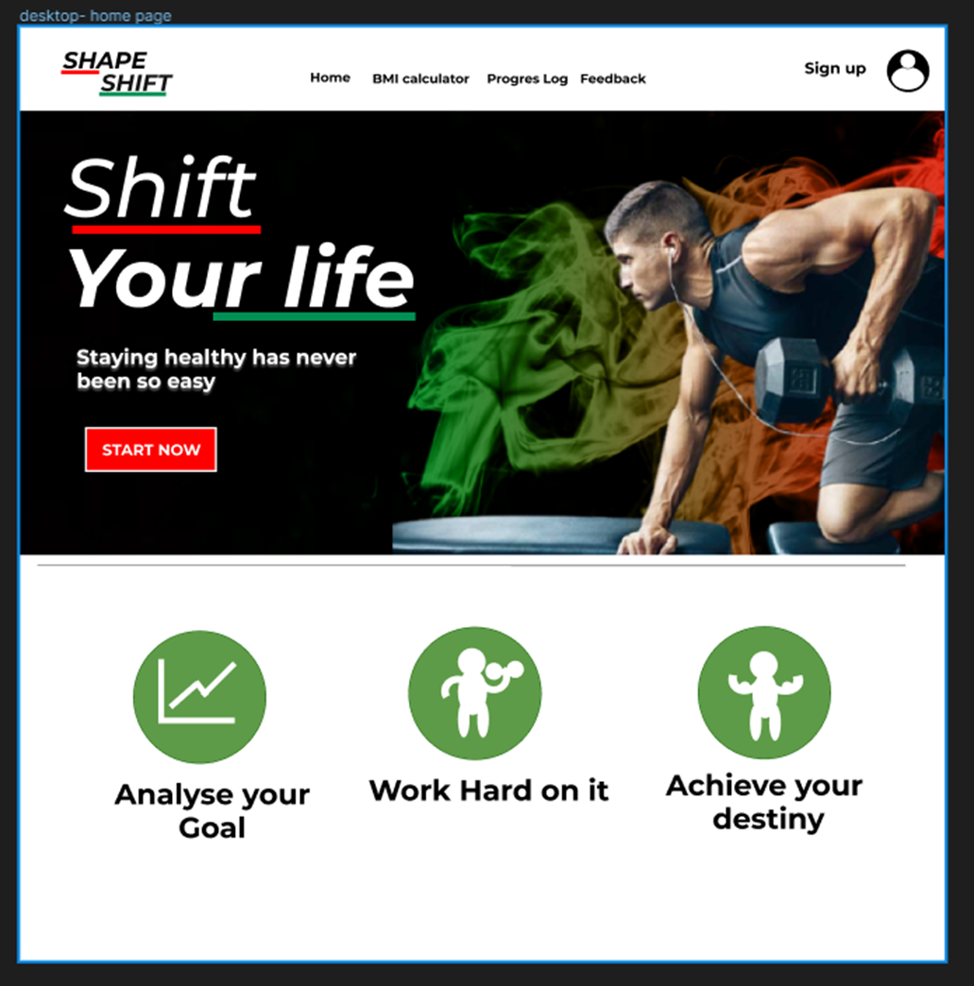

Login/signup page - we decided to have two options as we will either need to sign in or sign up. Socials were added as it would be easier for people to login rather than to add their details in every time.

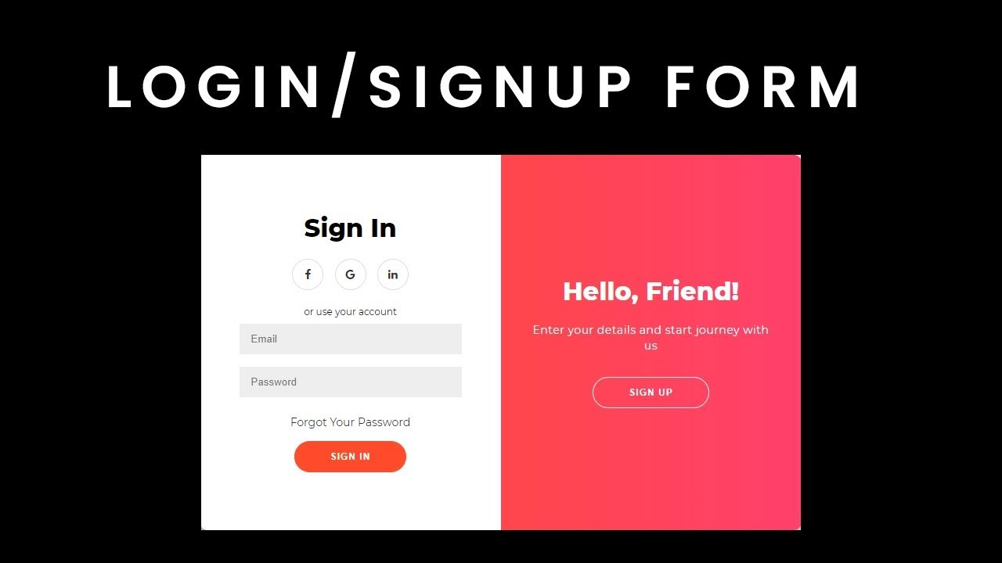

Pricing plan page- These will be based on what people can afford as well as the difficulty level since people will be at different levels.

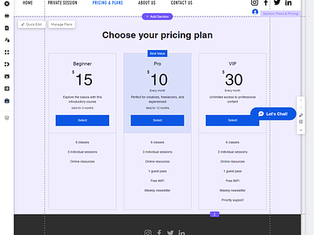

BMI Calculator Page

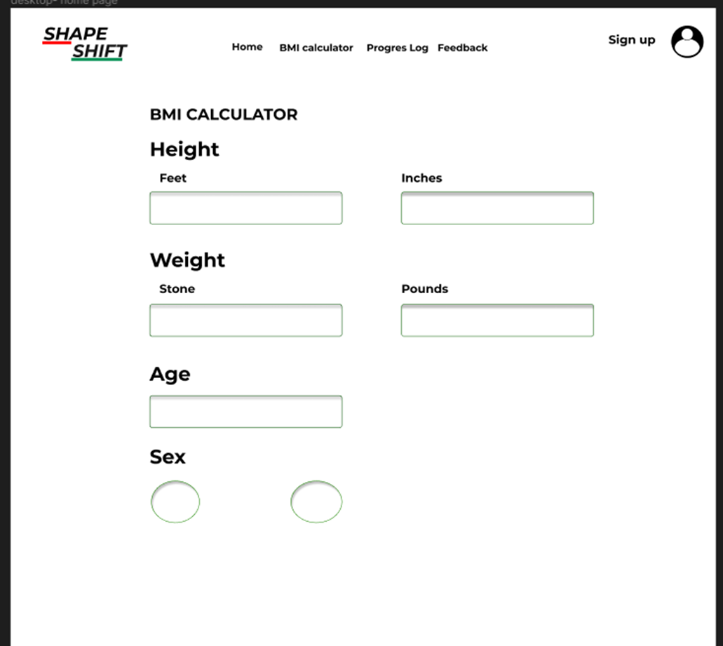

Feedback page - This will help us know whether we are making the right plan or not as well as it can help us get a higher rating on google and on other sites.

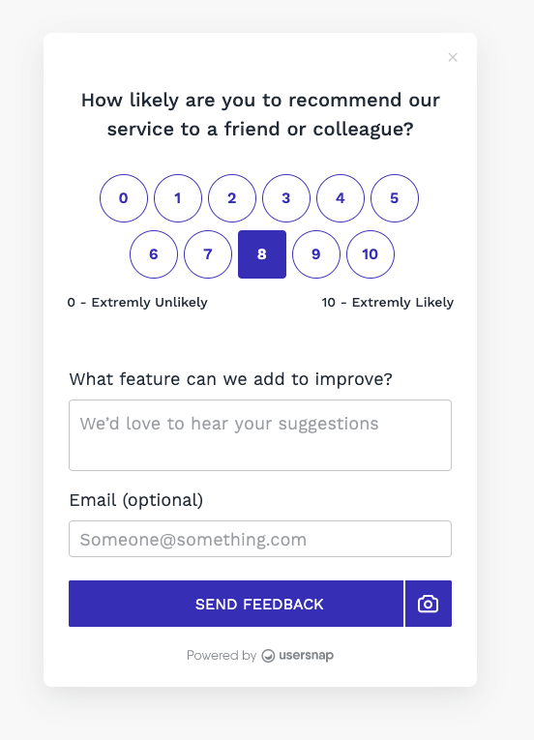

|  |  |
| --- | --- |
|  |  |

# 

# 

# 

# 

# **Purpose**

The purpose behind this application is to allow individuals to monitor their progress and receive personalised feedback and instructions which can act as a personal fitness companion. The primary purpose of such an application is to provide an easier and convenient route to achieving and maintaining physical wellbeing

The tool may give users a baseline evaluation of their body composition by calculating BMI, which enables them to track their progress and set reasonable targets. Furthermore, providing a variety of gym exercises based on personal preferences and fitness levels helps inspire members to continuously push themselves. Moreover, the provision of food suggestions and calorie monitoring functionalities endows users with the ability to make knowledgeable dietary decisions, guaranteeing that they take in a well-rounded and nourishing diet that is in line with their fitness goals.

# **System Development**

The development of our system required many resources, some that were unfamiliar to us. For the back-end we used [node.js/expres](http://node.js/express)s, and the front-end we used HTML, CSS and Javascript. At the beginning of our development, the team started with the backend first in order to create routes for our web application.

Node.js was useful in providing already existing modules of code to help us make our code run efficiently. 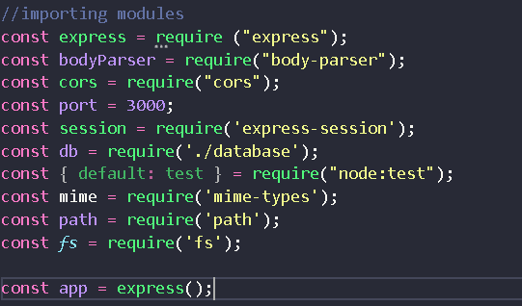

This was the list of modules that we have used in our project. Each module served a different purpose and was valuable in the development of our web application. Firstly, we decided to create a database that stores user information such as their email name password and the fitness plan they wanted to choose. We faced many challenges creating the database. The original plan was to create the database out of MySQL but it needed a server to run indefinitely. Not having access to a server meant that the user must create a database to run the code. The team has ultimately decided on using another database which is SQLite. SQLite is used for smaller traffic web sites whereas MySQL can handle multiple users. Our project was made for multiple users in mind, but this is an area we can improve in and if the team decides to continue the project or any following projects, MySQL will be used instead. 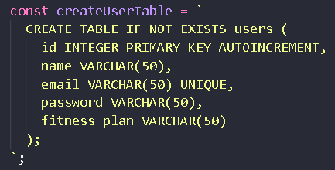

We created a table of users inside of the database. It stores the values we need inside of our database such as name, email, password and fitness plan.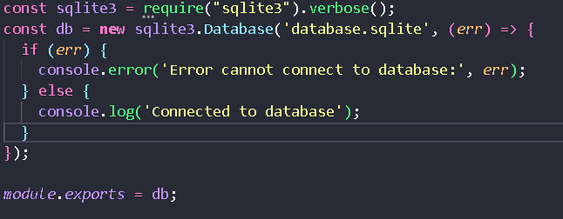

SQLite module used to create the database and to test the deployment of the database we had to run a query in the database to create a table inside of our database. Error handling was vital in helping us create our web application. We have used it extensively to record values and to review code that would be difficult for us to understand.

We used a post method to create a signup page. This post method took user information and it was sourced into a database. To test the database, we created test accounts to check if all the data was stored correctly.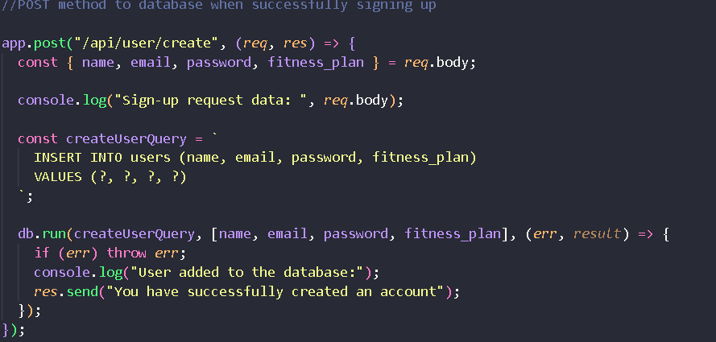

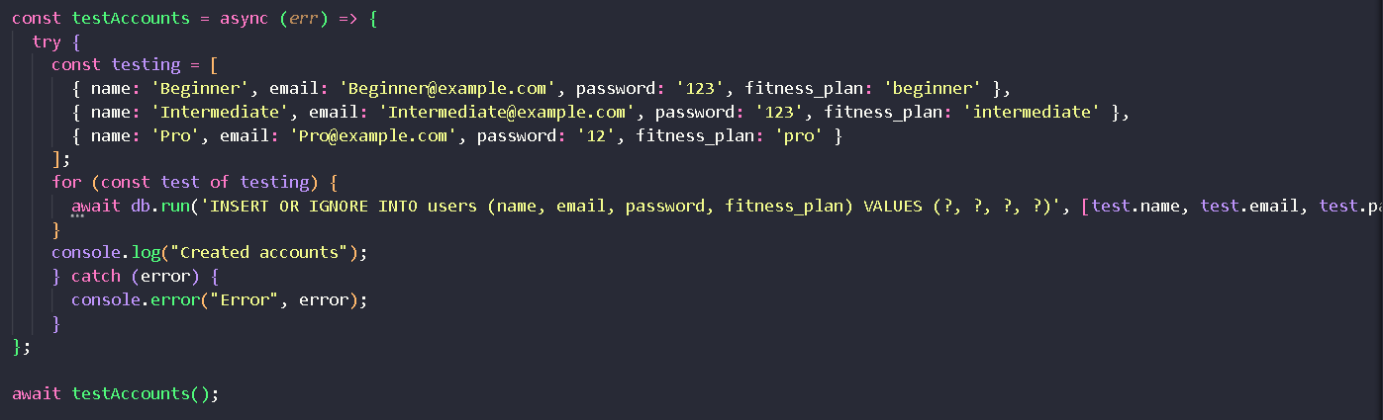

These test accounts were created to check if the values were being parsed properly into the database. Error handling was used to check the values of the code at certain lines, to help speed the process of finding corrupted data or wrongly parsed data.

When the sign up page was complete, we created the login page. We used an api to create our login page functionality. A javascript file located in the front-end was used to fetch the data from the post method. It would create a database query that searches for the id and fitness plan of a user after inputting the correct email value and password value.

An API was created to handle the routes between the fitness plan. Depending on the user's fitness plan, they are redirected to the fitness plan page they are in.

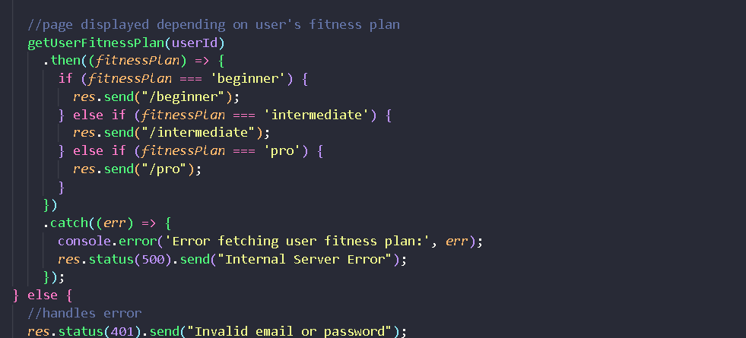

This handles the route of the user after they log into the web app. The fitness plan link will vary depending on the user’s chosen fitness plan.

During the development of our web application we created a feedback form or review form. Users can check other reviews of the web app and give feedback on how to improve the site. This implementation was very difficult and took a great deal of time.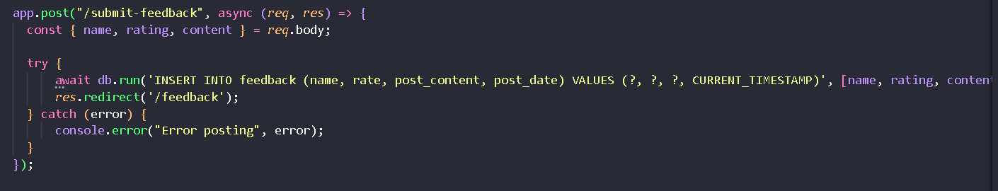

When users click on the submit feedback button a post method is called and then fetched by another javascript file. It stores the user's name and the rating they gave.

# **Evaluation of project**

Throughout the development of our project, the team had to overcome many design choices due to time restraints. As such, some ideas had to be removed or altered to fit these new contingencies. The group has done well to create a seamless experience for users and the metric of our success is the effectiveness of our web application promoting a healthier lifestyle among the South Asian community. The team provided a set of dietary and fitness regimes for 3 different levels of the fitness plans, users follow the regimes and pick the one that is most suitable for them. The team has considered that users can have no experience in fitness and thus, not be comfortable or afraid they may hurt themselves in the process of working out. Some users may not have the skill or talent to cook for themselves. To counteract this problem, the team have provided videos alongside textual information to further aid users who have little to no experience in a lifestyle based around fitness. This encourages users to practise the opportunity, learning how to complete a workout and reduces the amount of users who may be discouraged from the intensity of a fitness lifestyle. One possible way to improve this feature would be to expand our knowledge on creative web design. This will increase our skills in organising the data so that accessibility and usability performance does not degrade, thus ruining the user’s experience. We have addressed this weakness by separating content through the fitness plans. User’s decide the pace of their regime, reducing the risk of overwhelming and potentially losing a user due to the lack of free time that isn’t available for most people. As soon as users enter the fitness plan page, they are met with videos and instructions straight away. A flaw of our page design is the lack of filters and organisation. We intended on creating our fitness page displaying all information needed to start a workout. This cuts down the time a user is scrolling and the user will be able to access the video faster. However, due to the organisation of our video layout, it is difficult to locate the video you want. In future, it is imperative that we learn from this as we create more projects or expand upon this project.For example, creating a search feature for the videos in the fitness plan page or creating a category for a certain muscle group. During the course of this project, the team has significantly improved their skills at web design due to the challenges we have faced. The team relied on each other to help in areas that the other could not succeed. An example is the creation of our API’s, to store data from the database and display it onto the server. The team did not have much background knowledge on node.js/express so the work was divided between us all to help reduce the risk of being overwhelmed. Compared to our project proposal, many ideas did not make it into the final iteration of our web application due to multiple reasons such as time constraints and resources. The deployment of our web application was not as we expected but we managed to deliver some of the key features from our web application that we believe to be beneficial to the South Asian community, such as a responsive web application that is portable. Another challenge we faced in the development of our web application is databases. The team did not have experience in this role, but we managed using the SQLite database to create an embedded database inside of our web application. Overall, the team performed at their best to deploy a functioning web application to encourage the South Asian community to participate in a healthier lifestyle.

Communication

Our group consists of members that have met each other recently, in order to gain confidence and become a team we had created group chats and spoke together as a group more often and got to know each other better allowing us to work better and confidently amongst each other, we use Discord , as this was the more popular software amongst us, to meet up and keep in touch with all members. Overtime we have kept messaging the group and planning meetings consistently and made a routine to find when everyone is available so that we can get together and plan out the project as well give updates to each other, this had helped the group alot as it made sure everyone was kept informed and people were clear on which tasks were required. Each of us struggled to get the work done, meaning that we had to help our team members so that they were up to date with their tasks. This was needed when we were coding as some members were a bit behind, meaning that we had to help them catch up so that the software could be tested on time. We could have planned our tasks better as we left some to the last minute. This was when we had to test our coding to see if it validated.

```````````````````

**Planning**

Gantt Chart gave us a higher level of understanding of our aims and objectives, thus guiding us throughout the building process of our fitness web application.

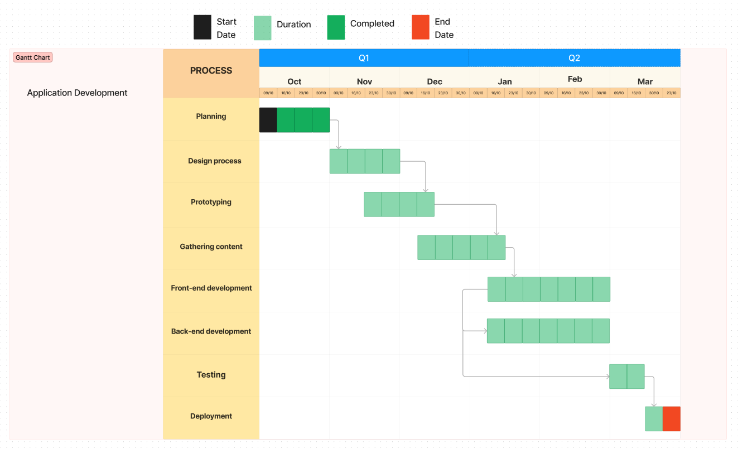

## Time Management

In order to meet deadlines and manage time we used a management tool called trello. Trello enabled us to have weekly meetings by making specific goals within the time frame of our higher level objectives.

During the designing process we opted to have weekly meetings, to which we used trello to track when the meeting will take place and who is able to participate in them.

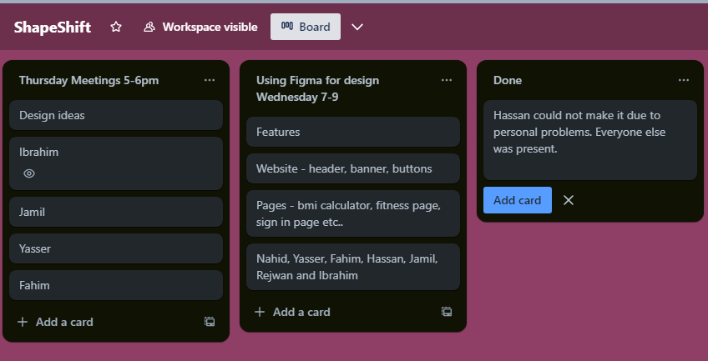

Trello helped us allocate team members into sessions or discussions which they are most effective in. Team management makes sure that everyone in the group understands the objectives, assignments, and due dates.

The team's ability to work together smoothly and accomplish the intended goals depends on this coordination. A well-managed team may pool ideas, viewpoints, and experiences through collaboration. The team's ability to think differently frequently results in more creative and practical solutions to issues or challenges. Flexibility and adaptability in response to unforeseen obstacles or changing conditions are encouraged by effective team management. 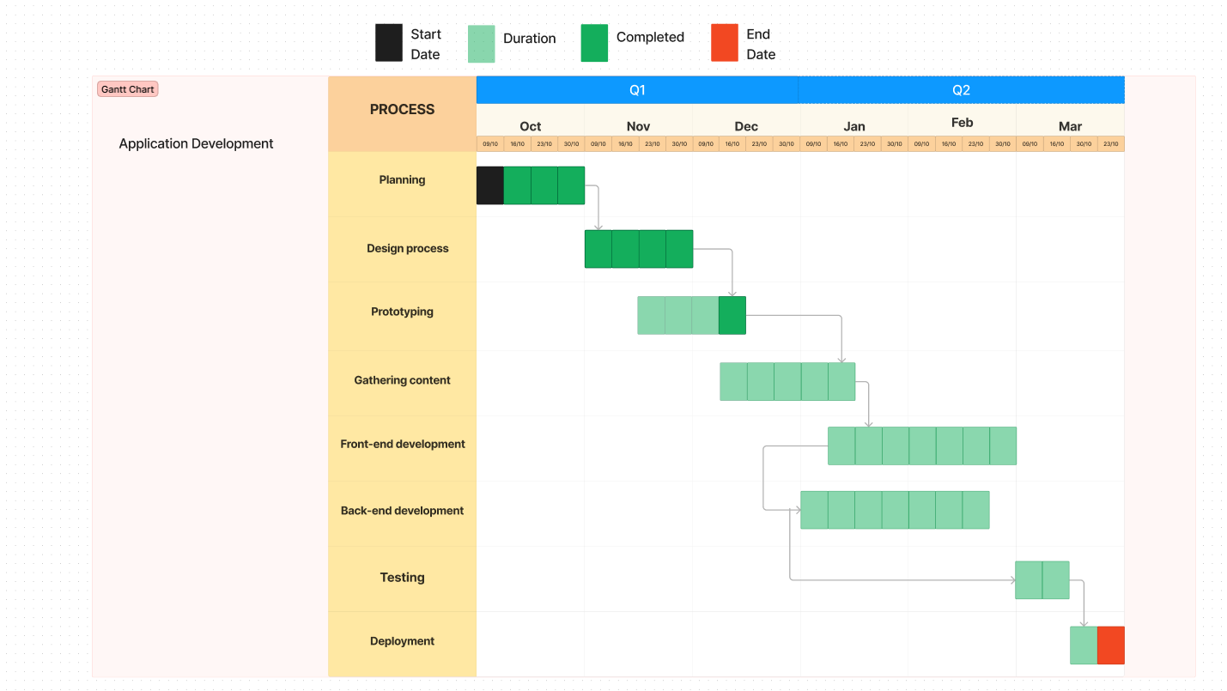

There were struggles of getting people on for meetings due to there being deadlines for other modules that people were committed to. This slowed down our productivity and led to a slack in prototyping the web application within the expected time frame.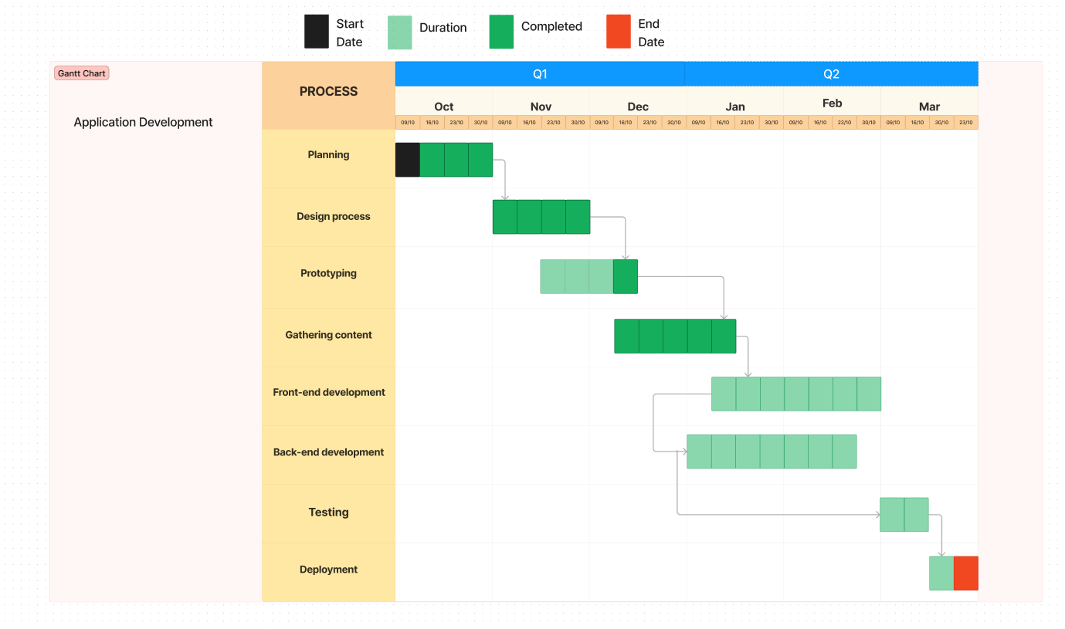

Content gathering was carried out during December by a group of members who were available and

teams are more capable of overcoming obstacles and overcoming uncertainty. As agreed throughout the team we decided to meet up at least once a week over discord so that we can update each other on our progress and make sure roles are distributed effectively and evenly, the time of the meeting varied as not everyone was free at the same time every week. Throughout our project a week of meetings was missed creating confusion amongst our team on what tasks were at hand, after this we realised that meetings were required and essential to our project.

# **Conclusion**

In conclusion, the team believes that our web application developed for South Asians will make a significant impact on promoting a healthier lifestyle to our stakeholders. The main objective of our web application was our intention to fulfil the needs of our stakeholders. Those needs were incorporating a friendly environment that motivated and encouraged our stakeholders to partake in daily fitness activities. Our goals were achieved as we managed to implement a simple user interface which is suitable for both of our young and old stakeholders. Although there were design choices that had to be scrapped or changed along the development process of our web application. We managed to implement what we believe to be the core functions of the web app. All users are able to create their own accounts and assign their own fitness plan. Users are met with an intuitive user interface that is responsive, allowing for a multi-platform experience. Feedback is vital to help us grow and learn from our failures, so the review/feedback page has been created in which users can create reviews or give feedback to the developers. With this, we can find our shortcomings and establish a connection with our users. Due to our stakeholders being of South Asian descent, most are not familiar with web applications. The feedback page granted us the ability to support our users. Compared to other fitness web applications that exist in the market. Our web application excels in offering customer support to ensure users are able to experience the best service we can provide. Moving forward from this project, we have taken into consideration the integral processes that developers use to create a comprehensive project based on the stakeholders needs such as the next project we develop it will use a framework on the front-end.

**References**

Published by Statista Research Department and 13, F. (2024) *UK fitness/Health Club Market Size 2022*, *Statista*. Available at: https://www.statista.com/statistics/1194831/fitness-health-club-market-size-uk/ (Accessed: 16 March 2024).

Nanditha A;Ma RC;Ramachandran A;Snehalatha C;Chan JC;Chia KS;Shaw JE;Zimmet PZ; (no date) *Diabetes in Asia and the Pacific: Implications for the global epidemic*, *Diabetes care*. Available at: https://pubmed.ncbi.nlm.nih.gov/26908931/#:~:text=More%20than%2060%25%20of%20the,to%20201.8%20million%20by%202035. (Accessed: 16 March 2024).